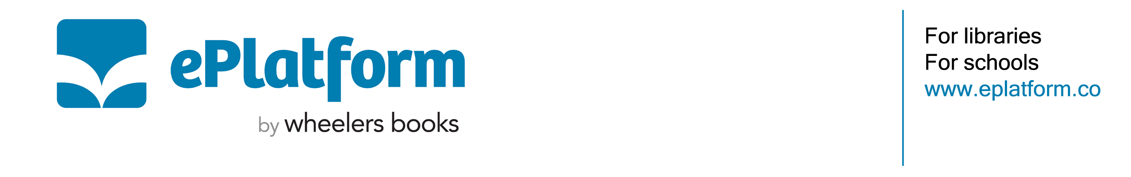
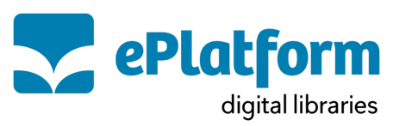

Letter to Parents Template

Dear Parents/Guardians

Our school is committed to providing students with unique learning opportunities, which is why we are pleased to introduce ePlatform, a digital library for students that provides free access to eBooks and Audiobooks.

The benefits of ePlatform Digital Libraries:
With ePlatform, your student has 24/7 access to eBooks and Audiobooks for free. This is a wonderful extension of our physical school library and allows titles to be checked out at home, over the weekend or during school breaks without worrying about losing or accruing late fees because they automatically return at the end of the loan period.

Students of all ages can benefit from ePlatform's reading and comprehension tools. A service like this can benefit struggling or reluctant readers, learning-challenged students, second-language learners, as well as gifted readers alike.
- Unique reader customisation with Settings Wizard, across all devices
- Introduce students to books above their reading level
- Help busy kids find time to read
- Professionally curated collection with age restrictions set by school staff
- Increase vocabulary and improve pronunciation and comprehension
- User friendly for all types of readers & listeners (e.g. reluctant, dyslexic)

How does it work?
Ensure your reader has the ePlatform app, which can be downloaded for free from the Apple Store, Google Play Store or visit eplatform.co to begin (called ‘ePlatform Digital Libraries). Students have their own unique login to access the platform. Please get in touch with us directly should your reader have any trouble logging in.

Kind regards,

School Librarian/Principal/Teaching Staff

