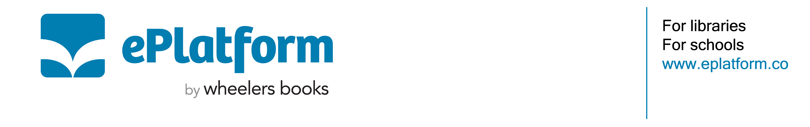
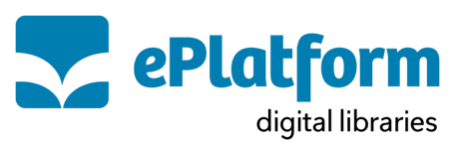

Letter to Parents Template – Refugee and Immigrant Families

Dear Families,

We are proud to offer your family access to a digital reading program designed to support children who are learning English. Our digital library, ePlatform, includes Decodable Readers and Levelled Readers that help young learners build confidence with reading and develop strong literacy skills in English.

This is a wonderful opportunity for families who are new to the country or learning English at home. The program is free and available 24/7 from home, making it easy for your child—and your whole family—to read, learn, and grow together.

What’s included:
- A structured reading program with 10 levels of Decodable and Levelled Readers
- Books designed to build English vocabulary, pronunciation, and comprehension
- Audio support and voiceover to help children hear the words as they read
- Activities, games, and worksheets to make learning fun
- Easy access on any phone, tablet, or computer—no need to visit the school or library
- Free to use, with no late fees or costs to worry about

Whether your child is just starting to learn English or already building their reading skills, these books offer a gentle and supportive way to practise each day. Many families also enjoy reading the books together as a way to build language at home.

In addition to these reading programs, families can also enjoy a wide selection of eBooks and Audiobooks for readers of all ages. Whether your child is a beginner or already reading independently, there is something for everyone.

Getting started is easy:
- Download the free ePlatform app from the Apple Store or Google Play, or visit eplatform.co
- Use your child’s school login to access the books (please contact your school if you need this)
- Choose a book from their reading level and start reading or listening together
- If you have any questions or need help logging in, please reach out. We are here to support you.

Warm regards,

[School Librarian/Principal/Teaching Staff]

