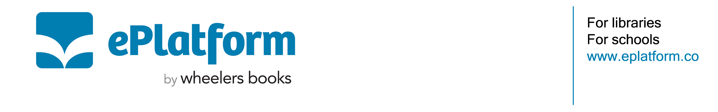
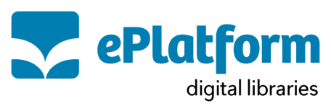

All Staff Email Template

Dear Staff,

Did you know [School Name]’s digital library, ePlatform, offers eBooks, Audiobooks and Decodable Readers available for students and staff? ePlatform is available 24/7 and all you need to get started is an internet connection and your [authentication requirements – i.e. Student ID, Email Address]. Check it out by downloading the ePlatform app. You can search by school name or enter this setup code: [setup code]

Our digital library offers students and staff a wide selection of reading material to support classroom learning and independent reading. From popular classics to new releases and curriculum titles, there is something for everyone, and your suggestions help us build the best possible digital collection for [School/District Name].

eBooks, Audiobooks and Decodables can be read in any web browser or downloaded via the ePlatform app to a smartphone, tablet, or computer. Titles return automatically at the end of the loan period, so there are no issues with late returns to manage.

We encourage all staff to explore ePlatform to browse what is available and how it works. If you have any questions or would like to suggest new titles, please contact [department or library contact name, email, phone number].

Thank you for supporting our students and for making the most of this resource yourself.

Kind regards,
[Library/Department Name]
[School Name]

